Research topic:

The Development of a Quantum Dot-Assisted Spectrum-Controlled Crop-Specific Greenhouse Tarp to Enhance Crop Yield

This research seeks to address the challenge of light spectrum optimization in controlled-environment agriculture by using advanced technology known as quantum dots to fine-tune crops' specific light needs at various stages of development to improve yield and quality. This research will ensure that each crop in greenhouse farming receives the needed light spectrum to enhance photosynthesis. This project will significantly increase crop yields and quality, combat food insecurity, and enhance agricultural sustainability.

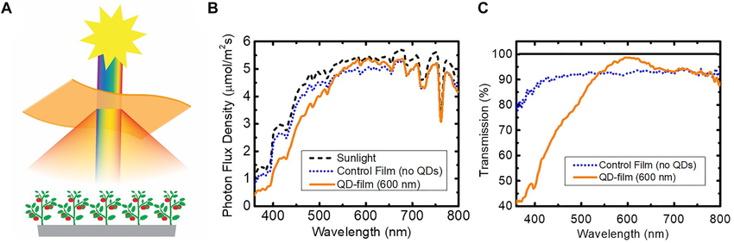

The sun

Different wavelength of solar spectrum

Quantum dots integrated greenhouse cover

Different wavelength through the quantum dots integrated greenhouse cover

Crops grown under quantum dots cover showing improved yields.

A schematic of quantum dots incorporated greenhouse cover absorbing light in different wavelengths and emitting in different wavelengths specific to crop needs.